|  |  |
| --- | --- |
| Chapter 9 Discussion Questions  ITRI 614 | Enrico Dreyer  31210783 |

Table of Contents

Question 1 3

Discuss changes in the job market for IT workers. 3

How do the job market and current state of the economy affect human resource management? 3

Question 2 3

Summarize the processes involved in project resource management. 3

Question 3 3

Briefly summarize the works of Maslow, Herzberg, McClelland, McGregor, Ouchi, Thamhain and Wilemon, and Covey. How do their theories relate to project management? 3

Maslow 3

Herzberg 4

McClelland 4

McGregor’s 4

Ouchi 4

Thamhain and Wilemon 4

Covey 4

Question 4 4

What is emotional intelligence (EI)? 4

Why is it important to develop EI skills? 4

Question 5 5

Describe a situation where it would be appropriate to use each of the six leadership styles described by Daniel Goleman. 5

Visionary 5

Coaching 5

Affiliative 5

Democratic 5

Pacesetting 5

Commanding 5

Question 6 5

Describe situations in which it would be appropriate to create a project organizational chart, a responsibility assignment matrix, a RACI chart, and a resource histogram. Describe what these charts or matrices look like. 5

Organizational chart 5

Responsibility assignment matrix 6

RACI chart 6

Resource histogram 7

Question 7 7

Discuss the difference between resource loading and resource levelling, and provide an example of when you would use each technique 7

Resource loading 7

Resource levelling 8

Question 8 9

Explain two types of team-building activities described in this chapter and discuss their advantages and disadvantages. 9

Physical challenging activities 9

Mental team-building activities 9

Question 9 9

Summarize the different ways that project managers can address conflicts to help them manage project teams. What can they do to manage virtual team members successfully? 9

Confrontation 9

Compromise 9

Smoothing 9

Forcing 9

Withdrawal 9

Virtual teams 9

Question 10 10

How can you use project management software to assist in project resource management? 10

# Question 1

# Discuss changes in the job market for IT workers.

There will always be a need for developers to maintain IT software, hardware, applications, and networks. The market for people who work in IT is getting bigger as well as the demand for project managers.

## How do the job market and current state of the economy affect human resource management?

With the focus on human resources, if people believe that the biggest asset in an organization is to fulfil the needs of human resources as well as the needs of individuals in the organization. By understanding how important project management is, it will increase the success of an IT project and boost the effectiveness of people in the organization.

# Question 2

## Summarize the processes involved in project resource management.

1. Planning resource management, this process involves how to acquire, estimate, use, and manage resources in the project.
2. Estimating activity resources, this process involves the estimation of physical and human resources that are needed to complete the work of the project.
3. Acquiring resources, this process includes obtaining facilities, team members, equipment, supplies, and any other resources.
4. Developing the project team, this process involves building group and individual skills to enhance the performance of the project.
5. Managing the project team, this process involves tracking the team’s performance, timely feedback, motivation of team members, resolving conflicts and issues.
6. Controlling resources, this process ensures that the resources are available as planned and monitoring what was planned with where the resources are up to this point.

# Question 3

## Briefly summarize the works of Maslow, Herzberg, McClelland, McGregor, Ouchi, Thamhain and Wilemon, and Covey. How do their theories relate to project management?

### Maslow

He was known best for developing a hierarchy of needs. He had the idea that humans are not the master of their own destiny, but their actions are controlled by unconscious processed that are determined by sexual urges.

### Herzberg

He was known best for the distinguishing of hygiene factors and motivational factors when thinking of motivation in a working environment. Tasks that cause job satisfaction were motivational factors and tasks that causes job dissatisfaction were hygiene factors.

### McClelland

He had the idea that a person’s needs are learned and acquired by life experiences, over the course of their lives. Power, achievement, and affiliation being the main categories where acquirement is achieved.

### McGregor’s

He was known best for the development of Theory X and Theory Y. In his studies he found that many mangers had great ideas but followed assumptions on worker motivation, and that all workers want to avoid and dislike work, but this simply is not true (Theory X). Where Theory Y was that all workers do not avoid or dislike work, and he motivated managers to view workers as in theory Y.

Ouchi

He introduced Theory Z, and is motivated off of the Japanese way of motivating people, and that is to put emphasis on quality, trust and cultural values.

### Thamhain and Wilemon

They investigated approaches that managers can use to handle workers and how different approaches can contribute to the success of the project.

### Covey

He developed and explained an approach on the helping of people and teams on how to become more effective by following simple habits that include, be proactive, begin with the end in mind, put first things first, think win/win, seek first to understand and then to be understood, synergize and finally to sharpen the saw.

# Question 4

## What is emotional intelligence (EI)?

This includes using more than one way to measure and think of human intelligence. This suggests the need for intrapersonal intelligence as well as interpersonal intelligence.

## Why is it important to develop EI skills?

For people to reach great results, emotional intelligence has an effect and plays a role in project managers working as a team. It improves team building, negotiation, collaboration and in general team relationship and development.

# Question 5

## Describe a situation where it would be appropriate to use each of the six leadership styles described by Daniel Goleman.

### Visionary

This is needed in an organization when the organization need to move into a new direction, and the goal of the organization needs to be shared between the people. The leader decides where the group is going and how to get there by experimenting, taking calculated risks and innovation.

### Coaching

This sets focus on individual development and improving their performance. This is used when individuals need assistance and show innovation.

### Affiliative

This in more of a focus on teamwork and having people connect with each other in harmony. This is there to improve communication and increase morale.

### Democratic

Sets the focus on people’s skills and knowledge and creates a sense of commitment to reach the goals of the organization. This works when the leader had a need for collecting wisdom from the group and what course of action needs to take place for the organization.

### Pacesetting

Setting high standards for performance. This is when a leader wants things to be done faster and better, when the leader expects more from the team and put in more effort.

### Commanding

This style is most often used, and the style is effective when a turnaround is drastically needed or when the organization is in crisis.

# Question 6

## Describe situations in which it would be appropriate to create a project organizational chart, a responsibility assignment matrix, a RACI chart, and a resource histogram. Describe what these charts or matrices look like.

### Organizational chart

An organizational chart is usually used for big projects that uses a matrix organizational structure. When there are a lot of people working on a project and a need for allocation and clear defining of project work.

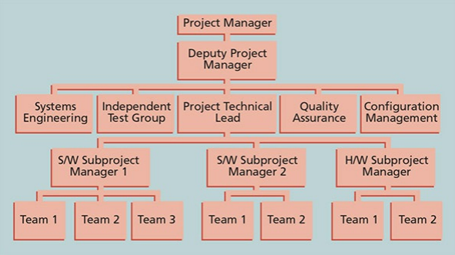

Figure : Organizational Chart

### Responsibility assignment matrix

This maps the work that needs to be done for a project and describes the responsibilities of the people doing the work.

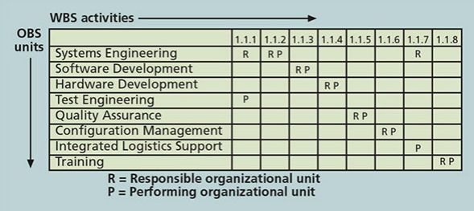

Figure : Responsibility assignment matrix

### RACI chart

Organizations use this chart to show the four key roles for project stakeholders, this includes responsibility, accountability, consultation, informed.

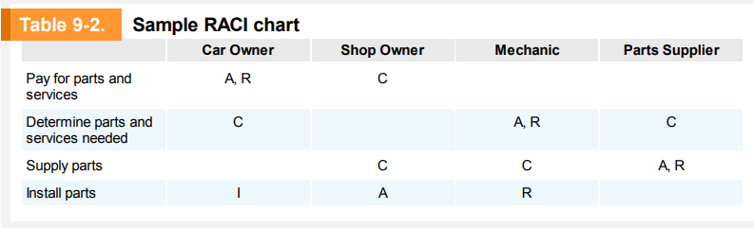

Figure : RACI chart

### Resource histogram

This is a column chart that displays the number of resources that are assigned to a project over time.

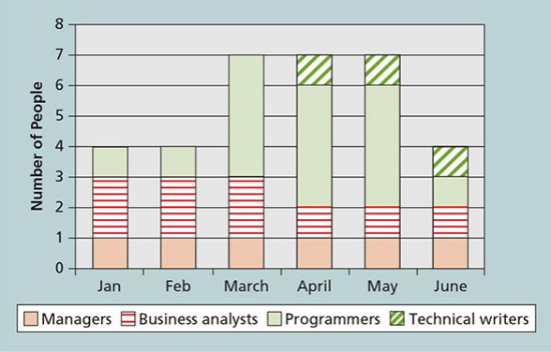

# Question 7

## Discuss the difference between resource loading and resource levelling, and provide an example of when you would use each technique

### Resource loading

This is the reference during specific time periods of an existing schedule, individual resources are indicated. This helps project managers better understand certain demands of a project, with the focus on individual schedules and the organizations resources.

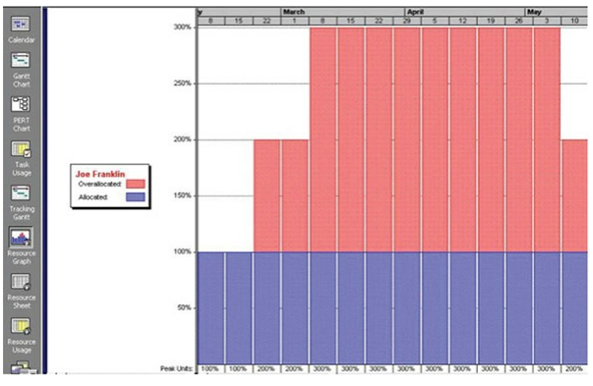

Figure : Resource loading example

### Resource levelling

This is a technique used for resolving resource conflicts caused by delaying tasks. This is the steps from start to finish. With the main objective being to create a better distribution of resource usage.

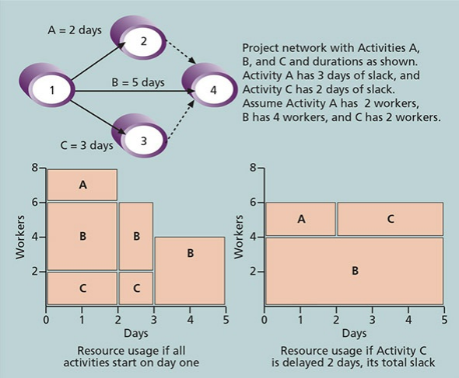

Figure : Resource levelling example

# Question 8

## Explain two types of team-building activities described in this chapter and discuss their advantages and disadvantages.

### Physical challenging activities

This is where teams have to go through physical training, like climbing rocks or mountains, navigating water rapids or do rope courses. This helps teams that do not know each other to work together but can have teams that are already difunctional have more problems.

### Mental team-building activities

This is where team learn about each other, themselves and how to work together as a group more effectively. The negative effect is that some people see this as an “easy off day” and not as a opportunity to strengthen the group, and thus wasting time and energy.

# Question 9

## Summarize the different ways that project managers can address conflicts to help them manage project teams. What can they do to manage virtual team members successfully?

### Confrontation

This is when project managers face conflicts head on with problem-solving approaches, this allows people to work through on their disagreements.

### Compromise

This is a give-and-take approach. Project managers count on solutions that give some kind of satisfaction from both sides of the conflict.

### Smoothing

Project managers avoids or deemphasizes areas or avoids areas of differences. They look to emphasize areas of agreement.

### Forcing

This can be seen as a win/lose approach. Project managers force out their viewpoint without looking at the other viewpoint.

### Withdrawal

This approach leaves project managers to withdraw or retreat from a potential or actual disagreement.

### Virtual teams

When possible, have the team talk to each other face-to-face before the virtual project starts. Project managers need to make sure that members can work together in a virtual environment.

# Question 10

## How can you use project management software to assist in project resource management?

* By using reports and stored information, you can keep track of resources.
* Identify resources that might need more attention, these resources might cause the project to miss deadlines and extend the time needed to complete the project.
* Reassign underutilized resources, this can shorten the duration of the project.
* By using automated levelling, project managers can make the levelling of resources easier to manage.
* Using software packages that make developing different graphs easier.